Assignment 8.2

Code :

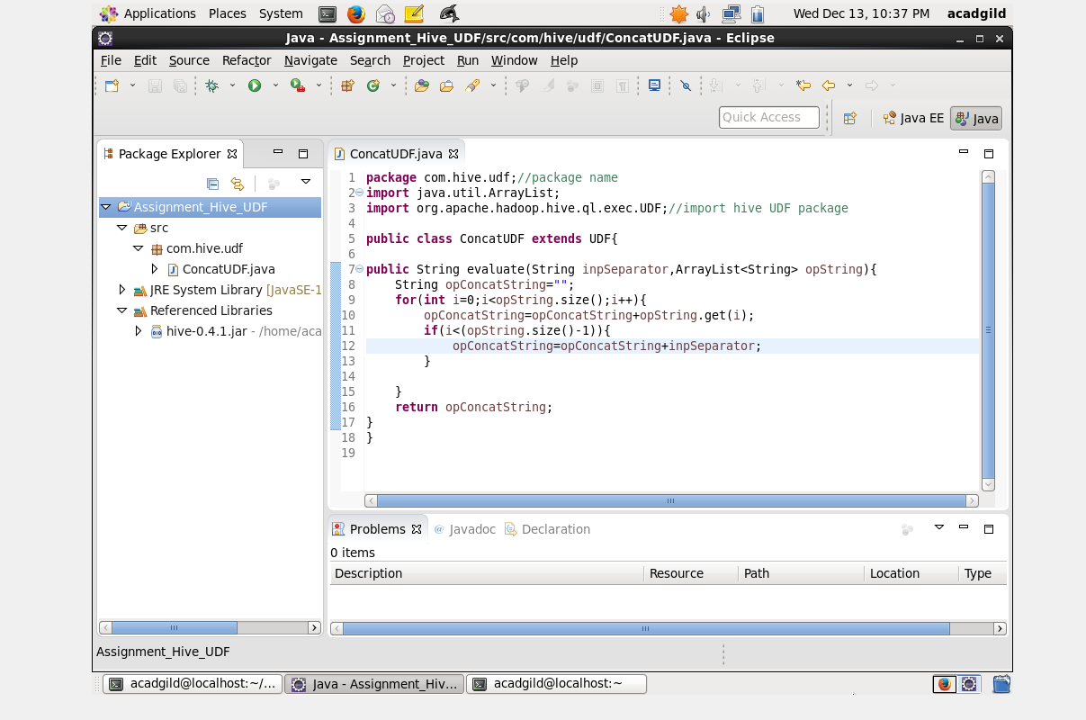

Create jar file for the above and add to hive

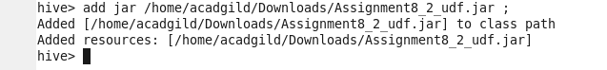



Create a table to test hive udf



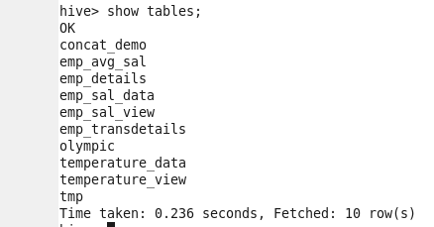

Load data to the table



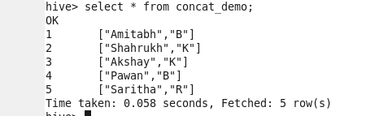

Now get the data using udf function

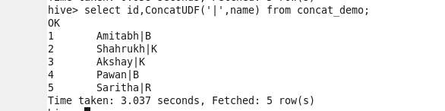

Output data is displayed with the separator specified in the query